DigiOne
Creating a DigiOne guardian account
DigiOne is an educational service platform that brings together all the information, systems, and services used by teachers, learners, administrators, guardians, and management into one user-easily digital service platform.
What is DigiOne?
- DigiOne manages your child’s educational affairs:
- You can view the students’ schedule (lessons).
- You can access information regarding education, academic support, and assessments (grades).
- You can communicate with school staff and receive general announcements (messages).
- You can report absences, submit absence requests, and track absence records.
- You can submit applications and receive decisions electronically.

How can I operate DigiOne?
You can get started with DigiOne by creating a guardian account. Guardian identity is verified in DigiOne using the Suomi.fi service. This verification requires a Finnish personal identity code. If a guardian does not have this code, the school will provide detailed instructions on alternative methods. Identity verification via DVV Suomi.fi: first-time login for guardians.
- Enter the login page address into your browser's address bar: http://app.digione.fi  - Open the page and select your preferred language. Click "Proceed" to create a username—this option is located below the "Log in" button.  - Click the "Get started" button.  - Select the "Guardian" (parent/guardian) role. Choose "Lahti" from the drop-down menu.  - Select the option: "I am logging in for the first time in the selected city."  - Click the "Continue to identity verification" button.  - The Suomi.fi identity verification system will provide options for you to verify your identity. You can do this using your online banking credentials or a mobile certificate.  - Click the "Continue to service" button.  - Create a username and a password.  - Your username will be your personal email address; please ensure it is entered correctly.  - The password must be at least 16 characters long.  - Enter your contact information in the designated fields, then click "Continue" to complete the registration.  - If the username is already in use, you will receive an error message; please choose a different username.  - Once a valid username and password have been set, the login page will appear.  - Enter your username (email address) and password into the designated fields.  - Then, click the "Log in" button. | 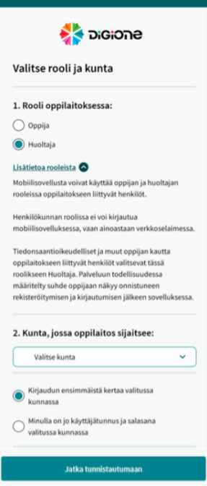

Email confirmation
Look for the confirmation email from DigiOne in your inbox, then click the confirmation link provided within it.
Note! When creating a parent account, you may encounter issues when clicking the link due to browser cookies (for example, the page might appear completely blank). In such cases, try the following solutions:
Enter "app.digione.fi" directly into your browser’s address bar, rather than clicking a link shared on a website or within a Wilma message. Try using private or incognito browsing mode. Ensure that pop-ups are enabled in your device settings. You can access DigiOne via the browser on your phone or computer; the display will automatically adjust to fit your screen size.
When you already have a DigiOne username for the parent/guardian
- Enter the login page address into your browser's address bar: http://app.digione.fi  - Open the page and select your preferred language. Click the "Log in" button. On the screen that appears, select the city where the educational institution is located.  - Select the option "I have a username (email) and password." Click the "Continue" button to proceed with the login.  - Enter your username and password.  - If you wish to remain logged in, check the box labeled "Stay logged in on this device."  - Click the "Log in" button.  Selecting a student  Choose the child whose affairs you wish to manage in DigiOne. All children for whom you are registered as a guardian will share the same identifier.  Adding the DigiOne button to your mobile device's home screen  It is recommended to add the DigiOne website as a shortcut to your phone's home screen. This will allow you to quickly access the application via that shortcut.  - Open the link http://app.digione.fi/ in your phone's web browser.  - Add the site to your phone's home screen:  In Safari, Chrome, or Firefox on iOS, tap "Share" and then select "Add to Home Screen" from the browser menu. In Chrome on Android, tap the three dots in the browser and select "Install" or "Add to Home screen" (to create a shortcut). | 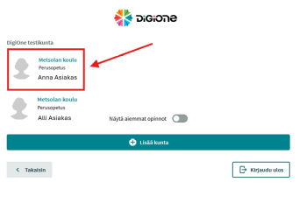  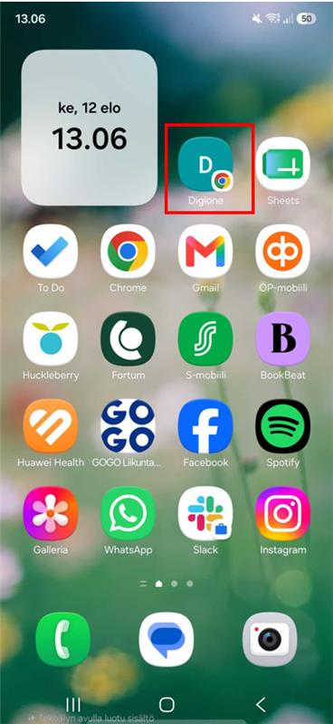
Instructions for resetting a forgotten password
- Go to http://app.digione.fi/  - Select the "Guardian" (parent/guardian) role, then choose "I already have a username and password for the selected city."  - Select "Continue to login."  - From the drop-down menu, select "Forgot password," then enter your email address.  - Click the link sent to your email, set a new password, then return to your browser and log in. | 