DigiOne's Guide for Guardians
DigiOne is an educational service platform that brings together all the information, systems, and services used by teachers, learners, administrators, guardians, and management into one user-easily digital service platform.
What is DigiOne?
- DigiOne manages your child’s educational affairs:
- You can view the students’ schedule (lessons).
- You can access information regarding education, academic support, and assessments (grades).
- You can communicate with school staff and receive general announcements (messages).
- You can report absences, submit absence requests, and track absence records.
- You can submit applications and receive decisions electronically.

View the home page and lesson schedule
When you select a student from the list, you will be taken to the home page. On the home page, you can view:  - A lesson schedule arranged vertically. You can browse the schedule by selecting the days of the week at the top.  - You can navigate to the following tabs in DigiOne:  Home  Studies  Communication (opened in a separate page)  Calendar  Other | 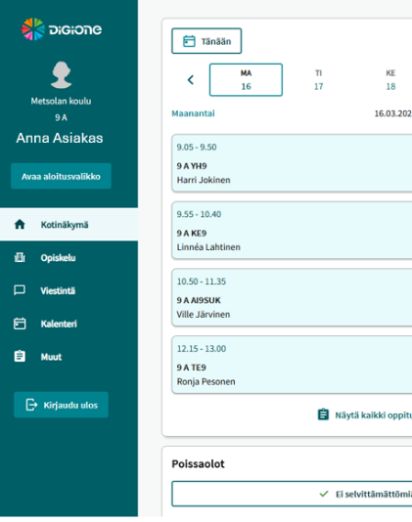
Homework and lesson content  Homework assignments set by the teacher and lesson content can be easily viewed via the home page—within the lesson schedule—by selecting "View all additional lesson information." | 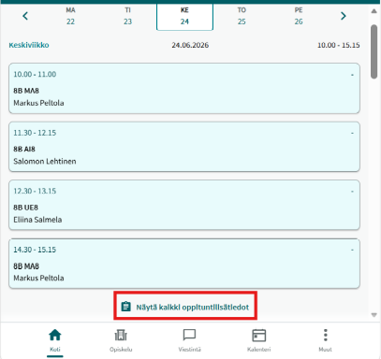
What does the school include?  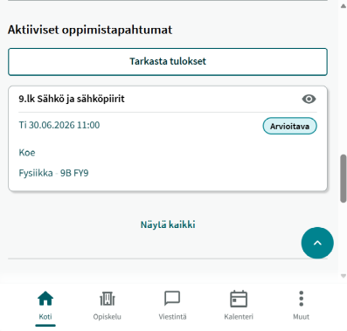 | 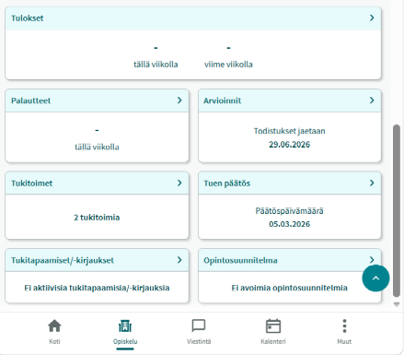
Reporting an absence
You can report sudden or short-term absences using the "Absence" button in the home page calendar. From the menu that appears, you can select the reason for the absence and its duration and specify whether it applies only to certain lessons or to the entire day. | 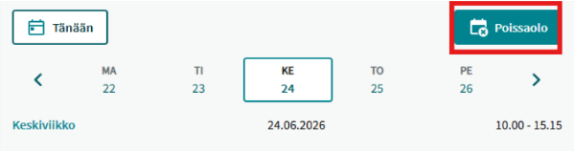
Reason for absence:  Health-related = Absence due to illness or a health-related event/visit.  Other = For example, a family emergency. Note! You cannot use this option for:  Requesting leave, such as for a trip. | 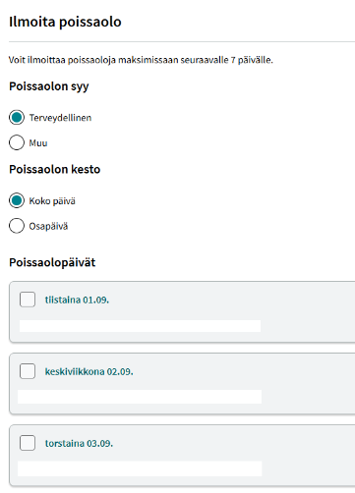
Identifying the reason for absence, tracking absences  - You can track your child’s absences via the "Absences" section on the home page or the "Studies" tab.  - The "View All" option displays all instances of absence.  - You can view absences by type using the "Filter" button at the top.  - If you need to provide an explanation for any absences, you can do so by using the "Clarify" button located below the unexplained absences. | 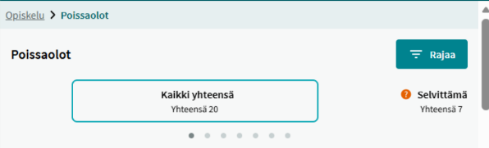
Submitting a leave request  • If an absence is known in advance, you can submit an absence request under the "Other" category.  • Select "Requests," then choose "Absence request."  • You will be directed to the Asiointi service, where you can provide the required information and submit the request to the school for processing by clicking the "Submit" button. The system will notify you that your request has been received. | 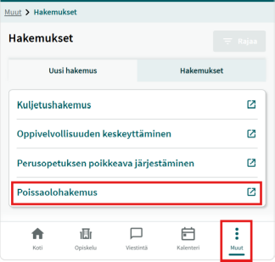
 | 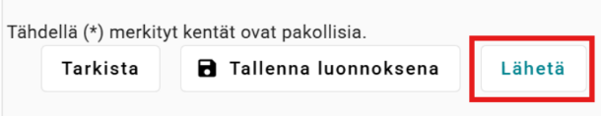

The teacher or administrator will process the leave request. While the request is being processed, it will appear in the requests section. | 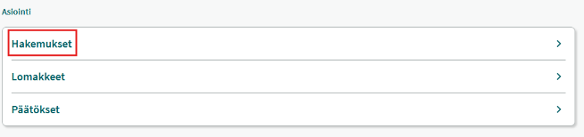
In the initial stages, the parent or guardian should also send a message to the teacher regarding the absence request. | 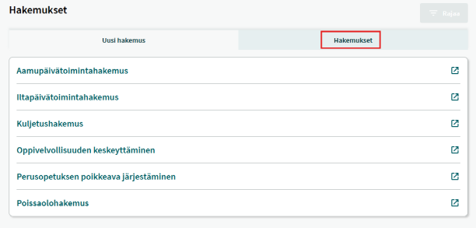
An approved leave request is displayed in the "Decisions" section within the application.  A rejected decision is also published on the Suomi.fi service. | 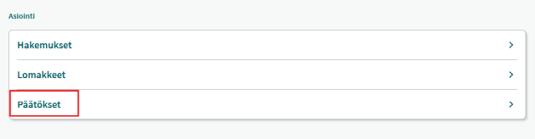

Communications service
- Communication within DigiOne takes place in a separate environment (Hailer).  - The communication service opens on a separate browser page.  - The communication service includes two main functions:  - Announcements (with guardians as the sole recipients)  - Discussions (private and group discussions)  Note!  • Discussions are linked to the individual person; for example, if a parent or guardian has a discussion with the same teacher regarding several different children, the messages will appear within the same thread.  • Even if a parent or guardian has children at multiple DigiOne schools (with different workspaces visible), all discussions and announcements will appear in the same view. In the future, it will be possible to filter announcements by school. | 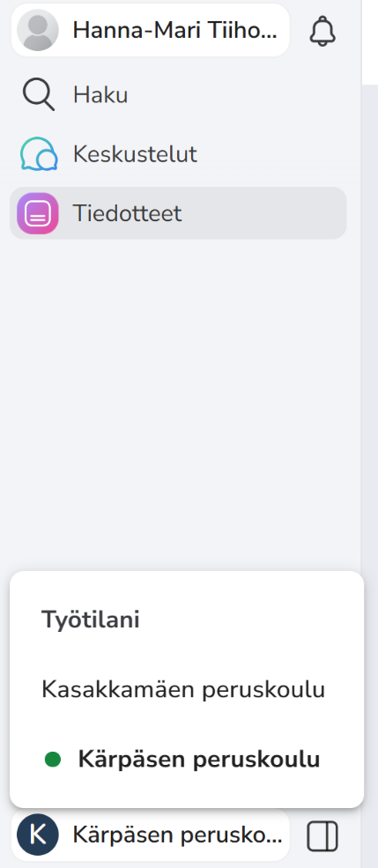

Important! Check your contact information and ensure it is kept up to date.

In case of an emergency, parents/guardians will be contacted by phone. Please be aware that parent/guardian contact information has not been transferred from the "Wilma" system to the "DigiOne" system.  Therefore, please ensure that your contact details in the "DigiOne" system are kept up to date, both now and in the future. | 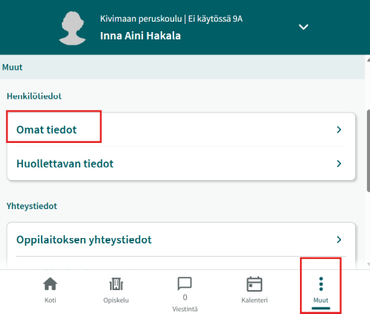
The guardian updates their contact information in the "Other Information / Personal Information" section. | 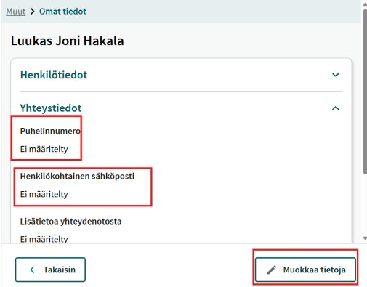
If you are unable to update your information, please fill out the incident report form immediately! This will also help us share your contact details with DigiOne. | 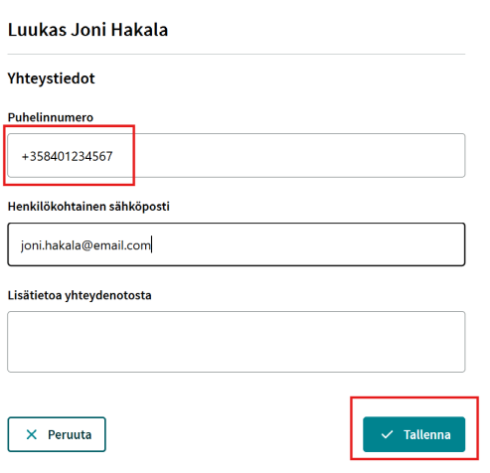
Resetting your password requires verification via email.  - To reset your password, you must confirm your email address.  - In this case, you can re-register via the login page by selecting "Logging in for the first time" or "I have forgotten my password."  - This will allow you to log in again and set a new password. | 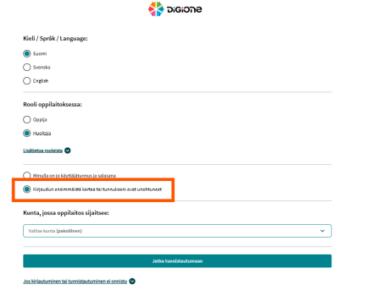

Instructions and a form for reporting a nuisance on the website lahti.fi
https://www.lahti.fi/kasvatus-ja-koulutus/perusopetus/digione/

If you encounter any issues or interruptions while logging into DigiOne or using the service, please report them using the DigiOne Lahti fault-reporting form.

- Please fill out the form as carefully and thoroughly as possible to help resolve your issue more quickly.

- DigiOne is still a work in progress. During this pilot phase, reports regarding faults and issues are crucial for ensuring that DigiOne functions optimally and provides the best possible service to everyone. Thank you for reporting any problems! ☺

